1.

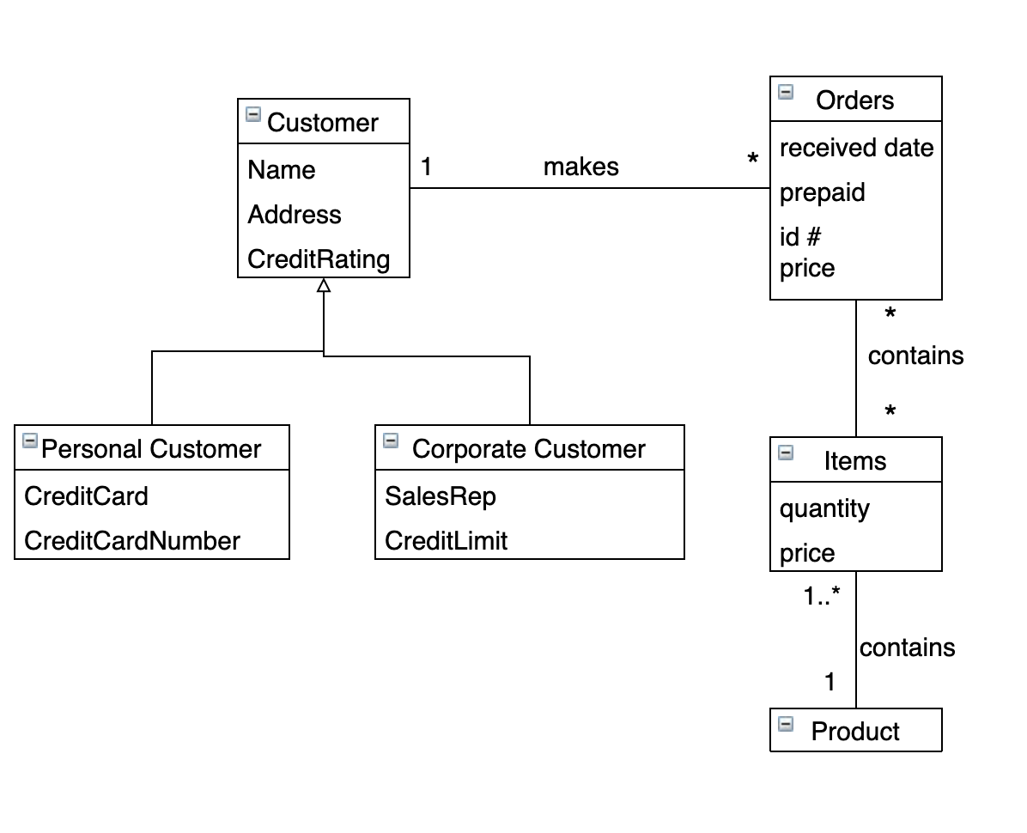

2.

1. A file inherits either the properties of a class for original files or from a class for directory files (generalization)

2. The records are part of the files and will be destroyed when the files are destroyed (composition)

3. A relation can be either an association or a generalization, so the association or generalization would inherit the properties from the relation (generalization)

4. A polygon consists of a set of points and when the polygon is destroyed, the points will be destroyed (composition)

5. There is an association between the person creating the program and the language they are using (association)

3.

A person is categorized by whether or not they are married and whether or not they are unemployed. They also have a birthdate, age, firstName, lastName, sex, and a computable income. A person can also be a wife or husband, and if so, can have a marriage with a place and a date. A person can also be a customer of a bank with 0 or 1 bank account numbers. A person can also be an employee or manager at zero or more companies. The company has a name and a number of employees. It also has a computable stockPrice. A person can have a job at this company with a title, startDate, and salary.

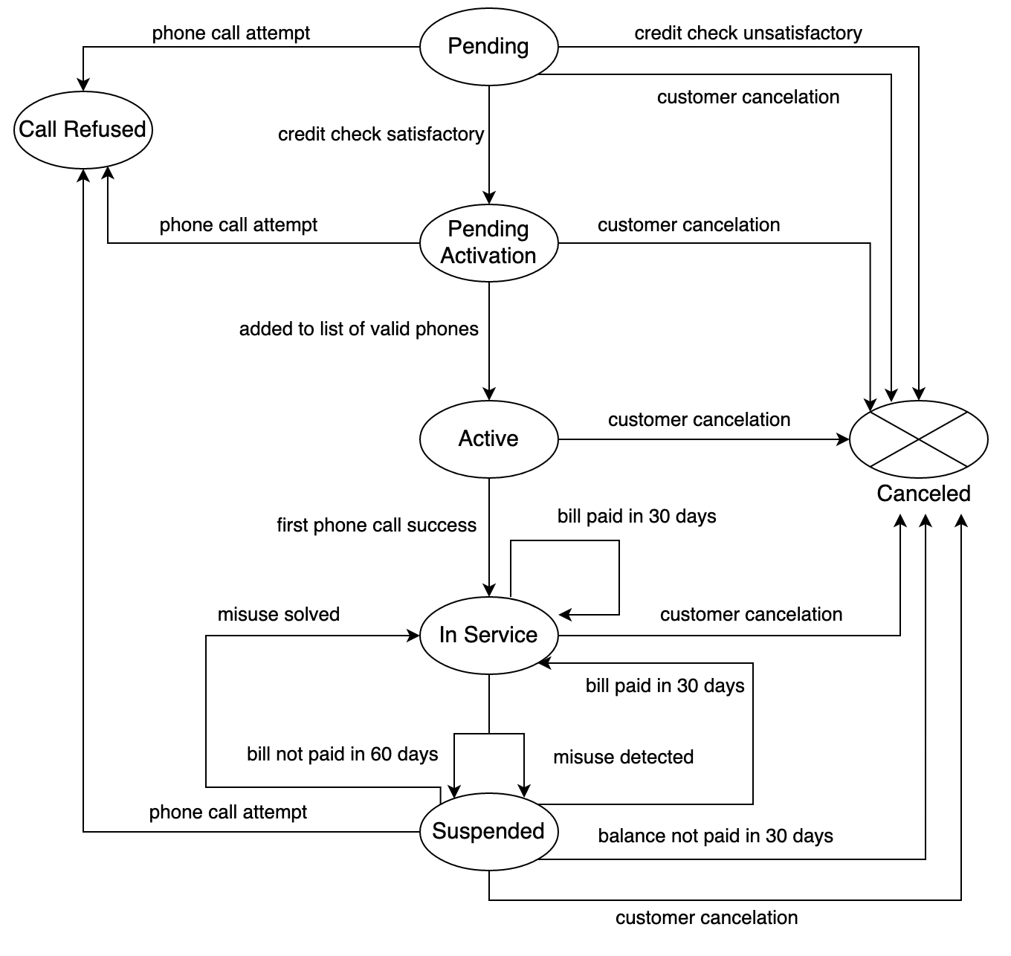4.

5.

In the cassette player’s initial state, the motor is stopped and the head is disengaged. It then enters the operational state. In the operational state, when s = off, it enters the final state (that being turned off). Also in the operational state, the cassette can be in the flipped state by setting s to flip and can be returned to operational by setting s to flip once more. It then enters the active state when the head is engaged and leaves the active state when the head is disengaged and goes back to operational. From there, it can be running when the motor is started and stop when the motor is stopped and returned to active. In the running state, it can be paused when s = pause and go to the pause state, and then started again if s = play and returned to the running state. The same can be said for stopping. When s = stop, it goes to the stop state and when s = play it returns to the running state.

6.

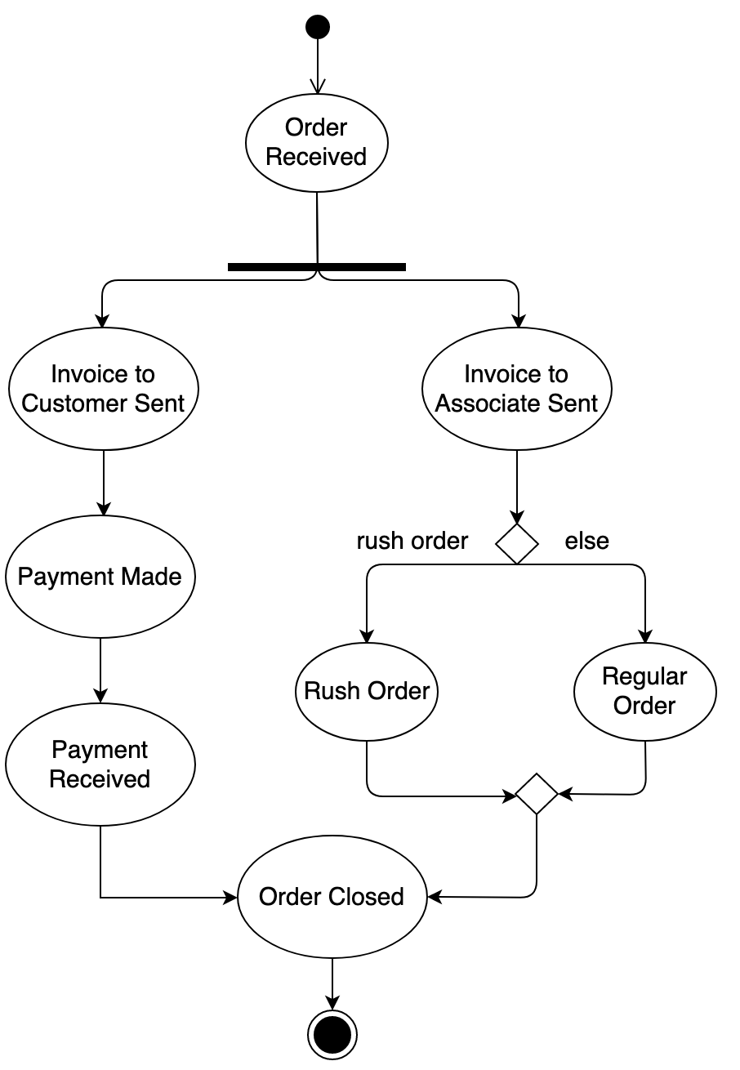

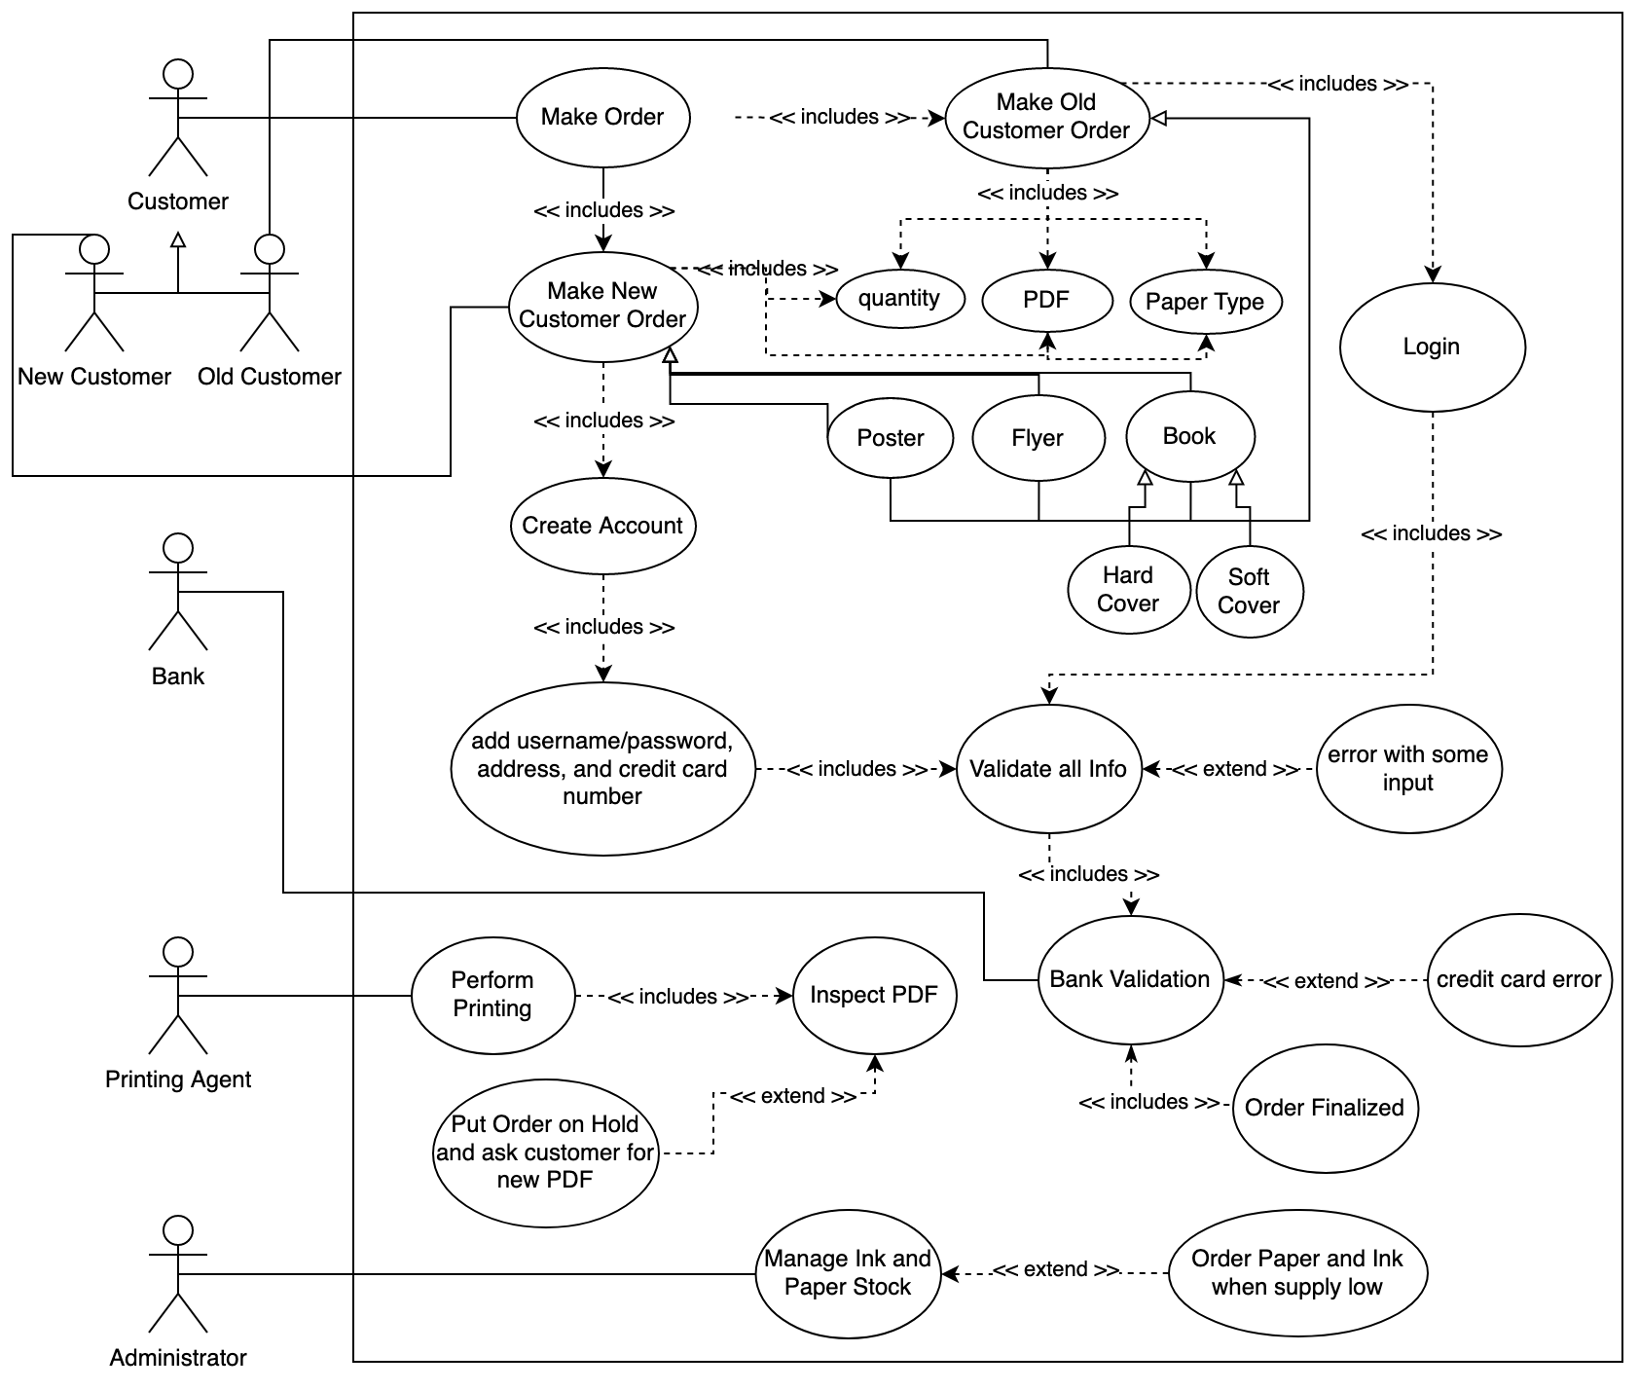7. Part A

7. Part B

Craig starts an order.

System asks if he is a new or returning customer.

Craig selects that he is a new customer.

System prompts him to enter his order information.

Craig selects poster as the print type, one as the quantity, gloss as his paper type, and uploads his PDF.

System prompts him to create an account.

Craig creates a username and password and enters his address and credit card number.

System validates all the info entered and finds no errors.

System sends credit card information to bank for verification.

Bank verifies and sends an all ok message to System.

System displays an order complete screen.

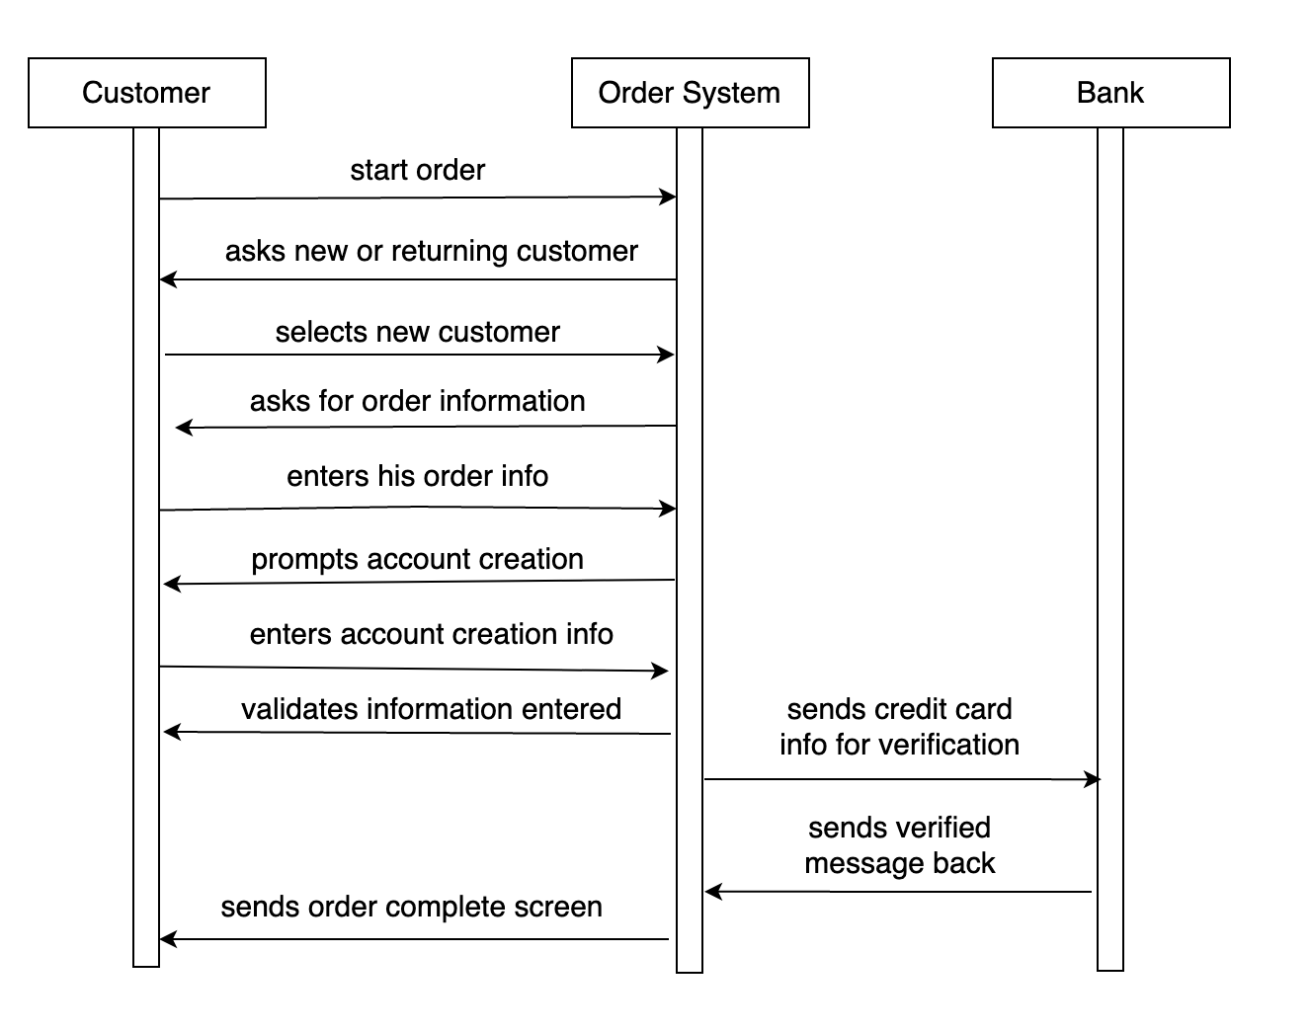7. Part C

7. Part D

